Stephanie Mecham
EPID 634

Lab #1 - Overview of MATLAB
Tasks

- Using the functions ones and zeros, and the various operators including the colon (':') operator, create the matrix
D = 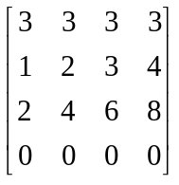
Hint: try typing D = [a1; a2; a3, a4], where the ai's are vectors created by using the ones and zeros functions, along with the colon operator

>> diary L1.txt

>> % Task One

>> a1 = 3*ones (1,4)

a1 =

3 3 3 3

>> a2 = 1:4

a2 =

1 2 3 4

>> a3=2:2:8

a3 =

2 4 6 8

>> a4= zeros (1,4)

a4 =

0 0 0 0

>> D = [a1; a2; a3; a4]

D =

3 3 3 3
1 2 3 4
2 4 6 8
0 0 0 0

- Extract the sub-matrix 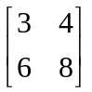 from the matrix D and assign it to d
>> % Task Two
>> d = D (2:3, 3:4)

d =

3 4
6 8

- Calculate 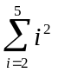, in a single command. Hint: There are two ways to accomplish this summation: 1) use the SUM function; 2) use a dot product by multiplying a row vector by a column vector. Try both methods. This provides you with two ways to calculate the sum of squares (to be used later in this lab and in Lab 2).

>> % Task Three

>> a=[2 3 4 5]

a =

2 3 4 5

>> b= sum(a.^2)

b =

54

- Type in the row vector, a = [2 4 7 11 16 22]. Using a single command, create a row vector consisting of the differences of successive elements from vector a. Hint: Consider using the colon operator. This provides you with an efficient way to calculate step changes in a vector; e.g., if vector a is a vector of times, then Δt is the incremental change in time (to be used later in this lab).

>> % Task Four

>> a = [2 4 7 11 16 22]

>> b=diff(a)

b =

2 3 4 5 6

II. Data manipulation
We will next learn how to manipulate and analyze data in two applications: human population growth, and infectious disease epidemics.

In this first application we will be using the data and analysis from Westing (Westing 1981). The first step is to load the human population data (you can access the file popdat.txt from the canvas site). The data comprises human population estimates from eight key dates, starting with the year 300,000 BC. This initial date is assumed to be the time in which Homo sapiens began to populate the Earth. Each date reflects a major transition that affected population growth. The data set contains two columns, date and population level. Note that BC dates are entered as negative numbers.

Population growth

Loading in and looking at the data
>> load popdat.txt
The data is retrieved from the current working directory and an 8 by 2 matrix is created called popdat. The first column is time and the second is population levels.
Typing the following will list the variable and its dimensions.
>> whos

>> %Data Manipulation
>>
>> %Population Growth

[Use import tool to import popdat.txt]

>> whos
Name Size Bytes Class Attributes

D 4x4 128 double
a 1x6 48 double
a1 1x4 32 double
a2 1x4 32 double
a3 1x4 32 double
a4 1x4 32 double
ans 1x4 32 double
b 1x5 40 double
d 2x2 32 double
popdat 8x2 1223 table

Typing the following will display the data.
>> popdat

>> popdat

popdat =

8×2 table

e005 e000
_________ _______

-2.98e+05 2
-40000 3e+06
-8000 5e+06
0 2e+08
1650 5e+08
1850 1e+09
1945 2.3e+09
1980 4.4e+09

Since there is such a huge range of values in the data, MATLAB does not provide ideal formatting. One way to look at the data is to look at it one column at a time
>> popdat(:,1)
lists all rows of column 1

>> popdat(:,1)

ans =

8×1 table

e005
_________

-2.98e+05
-40000
-8000
0
1650
1850
1945
1980

>> popdat(:,2)
lists all rows of column 2. Another way to look at the data is to plot it

>> popdat(:,2)

ans =

8×1 table

e000
_______

2
3e+06
5e+06
2e+08
5e+08
1e+09
2.3e+09
4.4e+09

>> plot(popdat(:,1), popdat(:,2))
To re-scale type
>> axis([-8000 2000 0 4.4e9])
or
>> axis([0 2000 0 4.4e9])
Assuming exponential growth, we can observe the shifts in per capita growth rates by plotting the log of the population data
>> plot(popdat(:,1), log(popdat(:,2)))
Or alternatively,
>> semilogy(popdat(:,1), popdat(:,2))
This can be best seen in two plots
>> axis([-300000 0 0 25])
shows the first three time periods and
>> axis([0 2000 19 22])
shows the last four time periods. Note: To see both time scales at once, first type
>>figure

This will provide you with a 2nd figure window. Then using the up-arrow key recall the plot command and replot. Then recall the axis command.
>> plot(popdat(:,1), log(popdat(:,2)))
>> axis([-300000 0 0 25])

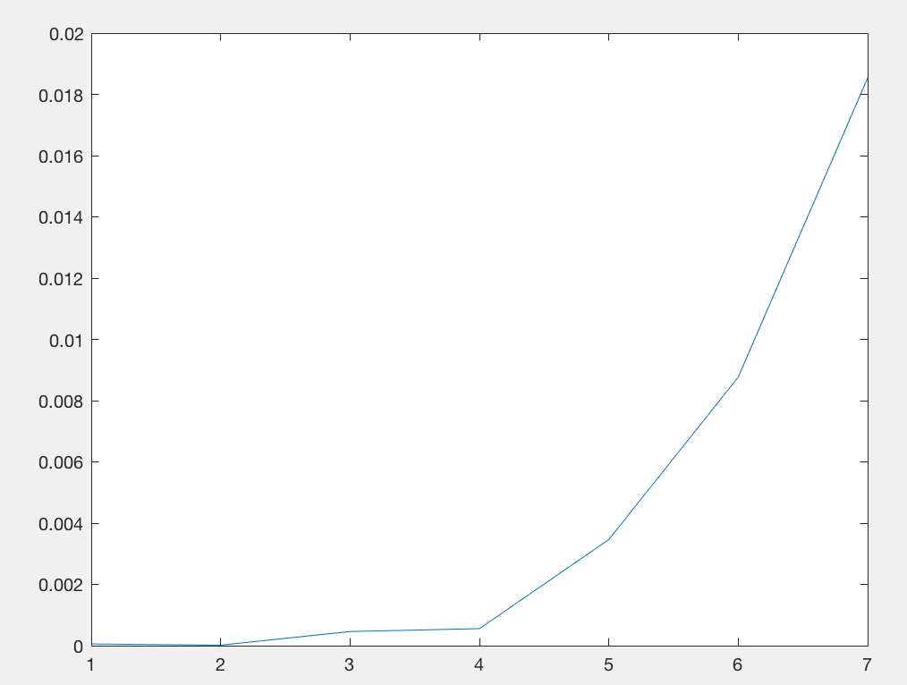

Analyzing the data
In his article, Westing analyzed the population data by assuming Malthusian or exponential growth, in which the per capita growth rate changes for each time period (Paleolithic, Mesolithic, Agricutural (BC), Agricultural (AD), Literate, Industrial, Nuclear).

Tasks:
- Calculate the growth rate for each time period and save it in a vector called r.
Hint: There are seven time periods each governed by the equation
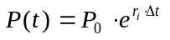
where P(t) is the current population level, P0 is the initial population level for each time period, ri is the per capita growth rate for the ith time period and Δt is the time period. For each time period you have two data points, the initial and final population levels.
You can use the approach from task 4 of the last section to calculate the growth rate.

>> rates=(a ./d)

rates =

0.0001
0.0000
0.0005
0.0006
0.0035
0.0088
0.0185

- From the growth rates calculate the doubling time (DT) for each time period, where DT = 0.69/r.

>> % Task Two

>> DT = 0.69 ./rates

DT =

1.0e+04 *

1.2518
4.3224
0.1496
0.1243
0.0199
0.0079
0.0037

- Graph the doubling time for the seven time periods. What can you conclude from this graph?

>> plot(DT)

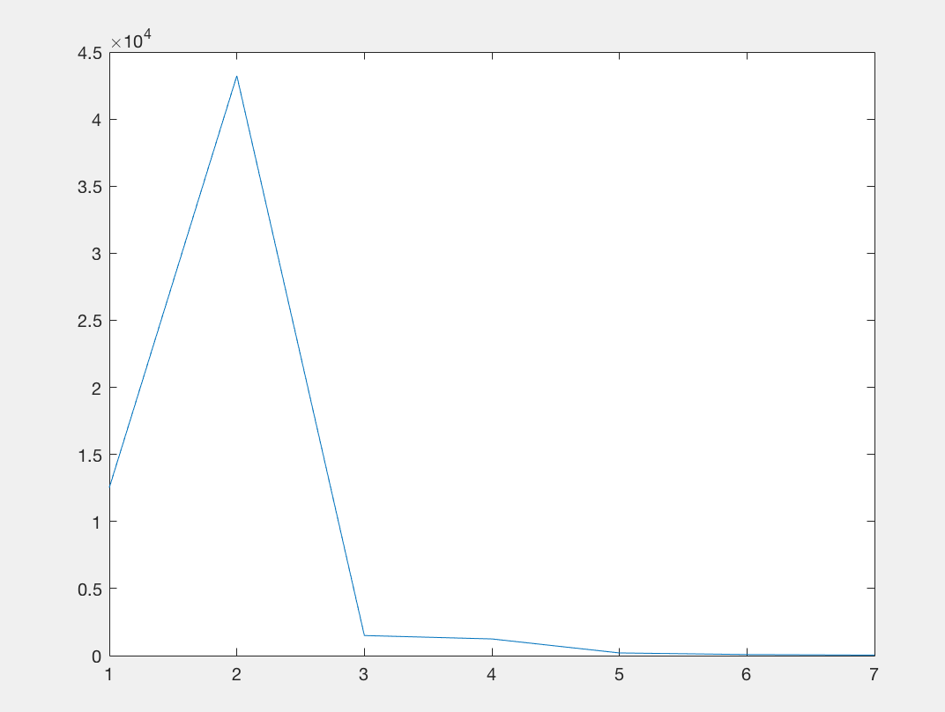

We can conclude that the growth rate sharply increases during the paleolithic period, maxes at the mesolithic period, then sharply decreases at the agricultural period and continues decreasing through the literate, industrial, and nuclear period.

- What are two basic assumptions of this piecewise exponential growth model?

We are assuming unlimited resources for population growth, and assume no seasonality (ie. continuous reproduction).

Saving your results
If you want to save your results to use later either in MATLAB or another program like Excel you can use the following command
>>save 'filename' X -ascii -tab
where filename will be the name of the file you will save it to, X is the matrix you are saving, -ascii is an option to save data in a text format, and -tab states you want the data tab delimited.

Note: If you are saving your work to use in MATLAB you can ignore the -ascii and -tabs options. If you are saving your data to use in Excel then it is often best to save one matrix at a time, since saving two matrices of different dimensions the row/column structure is compromised.

To save figures, cut and paste them in a Word document.

Epidemics

The Reed-Frost model
In the 1930's Reed and Frost developed a model that described an epidemic pattern of an acute, contagious infection after its introduction into a closed population. The model assumptions are outlined by Abbey (Abbey 1952).

The infection is spread directly from infected individuals to others by a certain kind of contact (adequate contact) and no other way. Any non-immune individual in the group, after such a contact with an infectious person in a given period, will develop the infection and will be infectious to others only within the following time period, after which he is wholly immune. Each individual has a fixed probability of coming into adequate contact with any other specified individual in the group within on time interval, and this probability is the same for every member of the group. The individuals are wholly segregated from others outside the group. These conditions remain constant during the epidemic.

The variables are:
1. St, St+1, the numbers of susceptibles during time interval t and t+1 respectively.
- Ct, Ct+1, the numbers of cases during time interval t and t+1 respectively.
And the parameter p = 1 - q is the probability that any two individuals come into "effective contact".
The probability that an individual comes into contact with none of the cases is qCt, and therefore the probability that an individual comes into contact with one or more cases is 1 - qCt. The model follows directly, i.e., the number of new cases at time t + 1 is
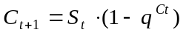

The following are the steps needed to simulate this model
c=zeros(15,1);
s=zeros(15,1);
c(1)= 1;
s(1)= 100;
for i=1:15
c(i+1) = s(i)*(1 - q^c(i));
s(i+1) = s(i) - c(i+1);
end

The new instruction used in this application is the for loop. You can type these commands, one at a time in the command window. However, since repeating these steps every time you want to run a simulation can be tedious, MATLAB allows you to write scripts, which are lines of instructions that you can save in a file. To create a script you would open up a new M-file using the MATLAB editor (in the MATLAB command window select file, new, m-file). Then type in the instructions and save the file with the name ReedFrost. You can then run these instructions by simply typing in ReedFrost. Instead of typing in these commands, you can also download the file named ReedFrost.m from the Canvas site.

Note: you will have to assign a value for the variable q, within the workspace before running the script.

Another script called ReedFrost1.m will be useful for the next two tasks. This script will both create the plots for Task 1 and collect the necessary information in a matrix for Task 2.

Task1:
For different values of q (0.99, 0.98, 0.97, etc.) and different initial number of susceptibles (100, 200, 500, etc), simulate the Reed-Frost model. For a few selected simulations, plot the number of susceptibles and number of cases vs. time within the same figure (hint: typing "hold" between two plots allows you to overlay curves).

>> % The Reed-Frost model
% Need to set initialize q in the workspace prior to
% running this script

>> q=0
q =

0
% Run script

c=zeros(15,1);
s=zeros(15,1);
c(1)= 1;
s(1)= 100;
for i=1:15
c(i+1) = s(i)*(1 - q^c(i));
s(i+1) = s(i) - c(i+1);
end
plot(c,':');
hold on;
plot(s,'--');
axis([1 16 0 s(1)]);
xlabel('Time');
ylabel(' Cases ( ... ) Susceptibles ( ---- ) ');
Ti = ['q = ' num2str(q)];
title(Ti);

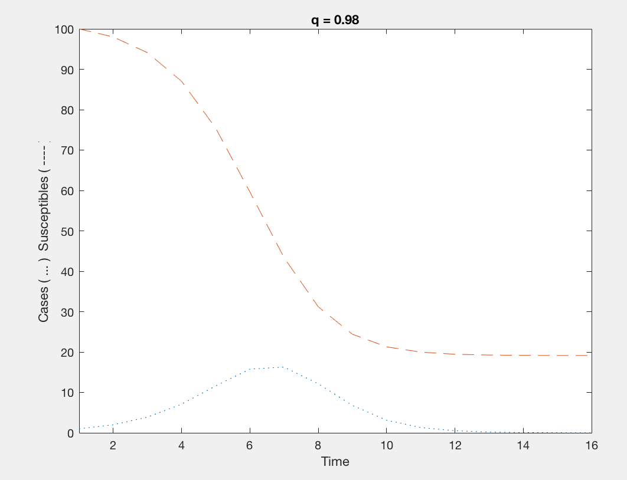

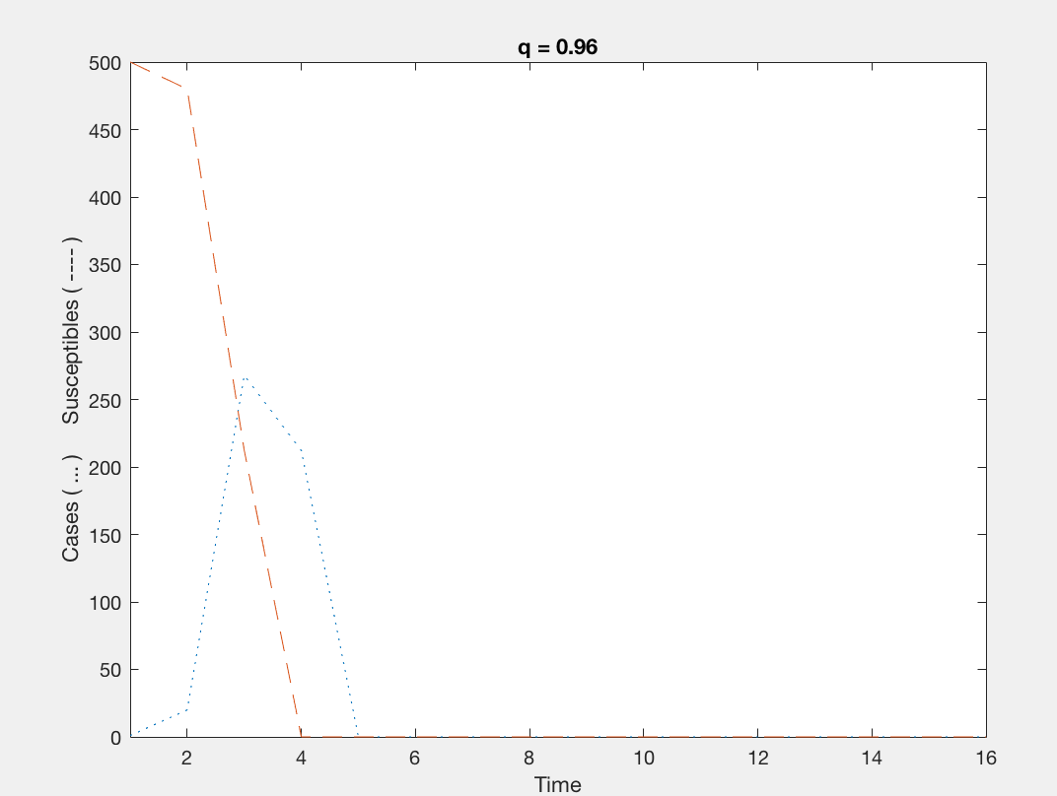

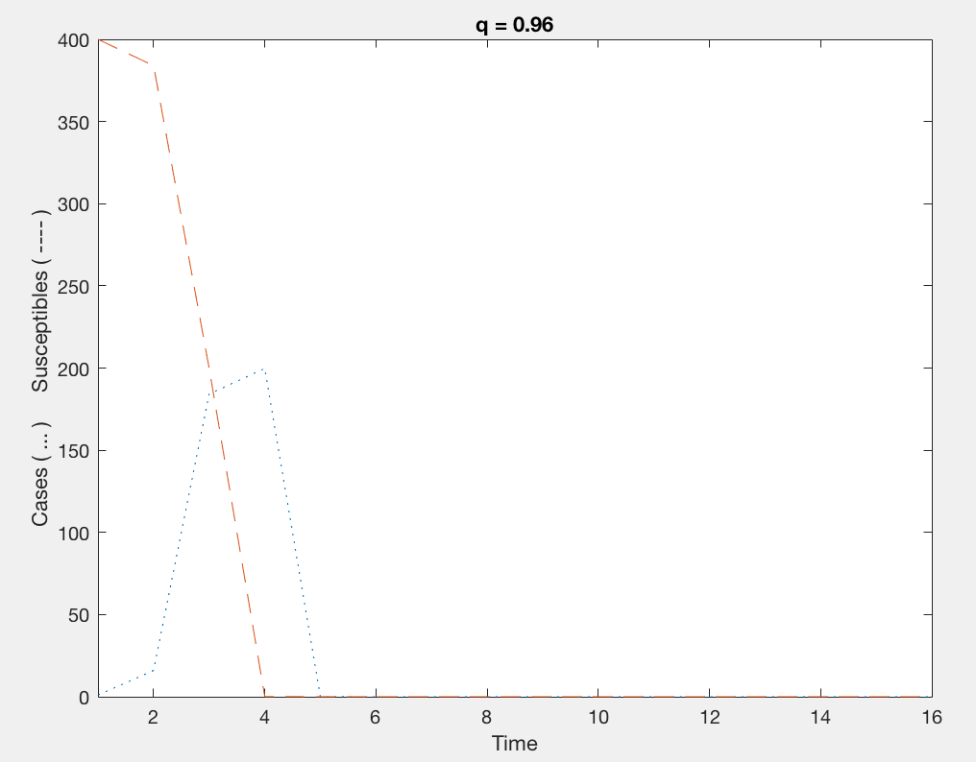

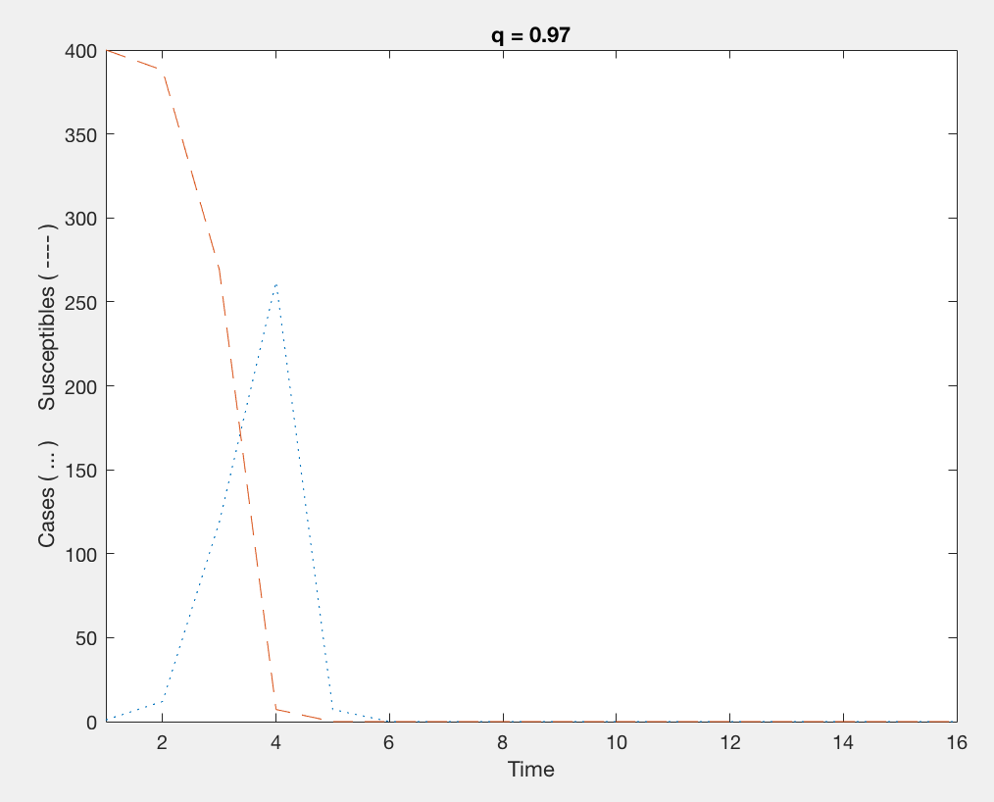

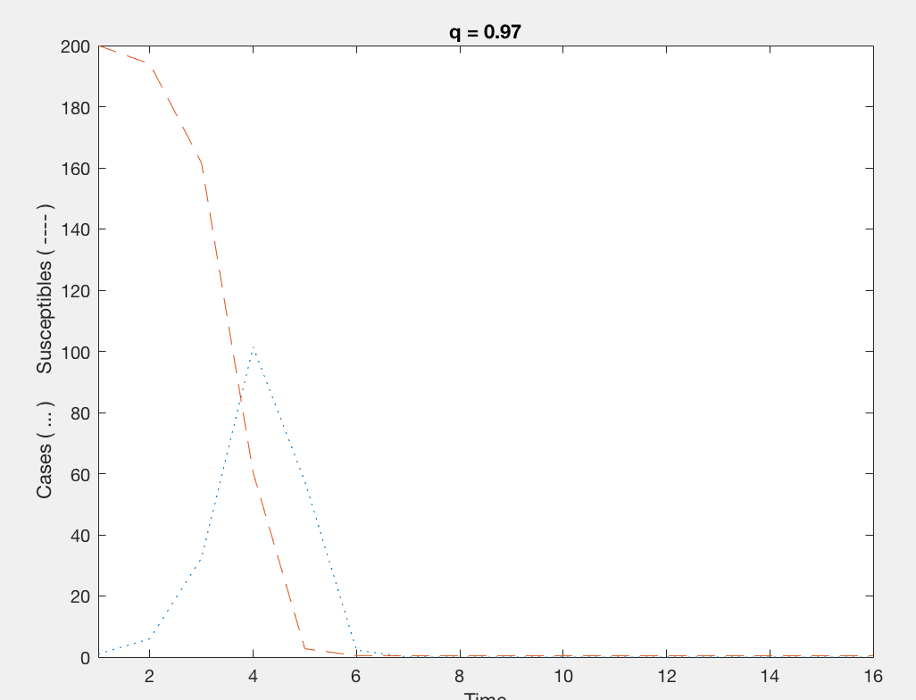

Q decreases final susceptibles dec, peak increases, and epidemic curve has shorter time-step

Sinitial inc. final suscept. Decreases. Peak inc. epidemic curve shorter

Discuss how q and Sinitial affects the behavior of the epidemic curve. Save and use a few of these time series plots to help illustrate these different epidemic characteristics (final number of suscecptibles (Sfinal), the peak number of cases (Cmax), and the time step corresponding to the peak number of cases (Tcmax).

The script ReedFrost1.m creates the following matrix.

q | S initial | S final | Cmax | TCmax | Q | S initial | S final | Cmax | TCmax
0.99 | 100 | 88.9252 | 1 | 2 | 0.97 | 100 | 5.4446 | 31.3530 | 5
0.99 | 200 | 39.4769 | 31.4740 | 8 | 0.97 | 200 | 0.4447 | 101.3696 | 4
0.99 | 300 | 17.3377 | 90.4868 | 6 | 0.97 | 300 | 0.0313 | 194.8113 | 4
0.99 | 400 | 7.6787 | 140.2798 | 6 | 0.97 | 400 | 0.0020 | 261.9878 | 4
0.99 | 500 | 3.3642 | 236.3550 | 5 | 0.97 | 500 | 0.0001 | 305.7642 | 4
0.98 | 100 | 19.1348 | 16.2749 | 7 | 0.96 | 100 | 1.7387 | 36.3569 | 4
0.98 | 200 | 3.7160 | 82.3719 | 5 | 0.96 | 200 | 0.0548 | 122.9076 | 4
0.98 | 300 | 0.6955 | 128.2380 | 4 | 0.96 | 300 | 0.0014 | 174.6018 | 4
0.98 | 400 | 0.1216 | 231.2140 | 4 | 0.96 | 400 | 0 | 199.7262 | 4
0.98 | 500 | 0.0201 | 334.9002 | 4 | 0.96 | 500 | 0 | 267.8388 | 4

Task2:
Collect data on the q, Sinitial and Sfinal and create two representative plots showing how the number of susceptibles after the end of the epidemic (Sfinal) depends on the contact rate (q) and the initial number of susceptibles (Sinitial). Plot Sinitial vs. Sfinal using a constant q, and plot q vs. Sfinal using a constant Sinitial.

(Hint: The function "find" will help extract the appropriate data for each plot from the matrix OP that is created in the script ReedFrost1. For example, the following two commands extract the rows in the above matrix, if Sinitial = 100, and places it into another matrix called SubOP

[R C] = find( OP(:,2) == 100 ) R is a vector consisting of the rows where there is a value of 100 in the second column
SubOP = OP(R, :) SubOP is a matrix using only the rows specified in R

>> j = 0;
OP = zeros(20,5);
for q = .99:-0.01:.96
for si=100:100:500
j=j+1;
hold off;
c=zeros(15,1);
s=zeros(15,1);
c(1)= 1;
s(1)= si;
for i=1:15
c(i+1) = s(i)*(1 - q^c(i));
s(i+1) = s(i) - c(i+1);
end
plot(c,':');
hold on;
plot(s,'--');
axis([1 16 0 si]);
xlabel('Time');
ylabel(' Cases ( ... ) Susceptibles ( ---- ) ');
Ti = ['q = ' num2str(q)];
title(Ti);
figure;
[Mx I] = max(c);
OP(j,:) = [q si s(16) Mx I];
end
end
OP

OP =

0.9900 100.0000 88.9252 1.0000 2.0000
0.9900 200.0000 39.4769 31.4740 8.0000
0.9900 300.0000 17.3377 90.4868 6.0000
0.9900 400.0000 7.6787 140.2798 6.0000
0.9900 500.0000 3.3642 236.3550 5.0000
0.9800 100.0000 19.1348 16.2749 7.0000
0.9800 200.0000 3.7160 82.3719 5.0000
0.9800 300.0000 0.6955 128.2380 4.0000
0.9800 400.0000 0.1216 231.2140 4.0000
0.9800 500.0000 0.0201 334.9002 4.0000
0.9700 100.0000 5.4446 31.3530 5.0000
0.9700 200.0000 0.4447 101.3696 4.0000
0.9700 300.0000 0.0313 194.8113 4.0000
0.9700 400.0000 0.0020 261.9878 4.0000
0.9700 500.0000 0.0001 305.7642 4.0000
0.9600 100.0000 1.7387 36.3569 4.0000
0.9600 200.0000 0.0548 122.9076 4.0000
0.9600 300.0000 0.0014 174.6018 4.0000
0.9600 400.0000 0.0000 199.7262 4.0000
0.9600 500.0000 0.0000 267.8388 3.0000

>>
>> [R C] = find( OP(:,2) == 100 )

R =

1
6
11
16

C =

1
1
1
1

>> SubOP = OP(R, :)

SubOP =

0.9900 100.0000 88.9252 1.0000 2.0000
0.9800 100.0000 19.1348 16.2749 7.0000
0.9700 100.0000 5.4446 31.3530 5.0000
0.9600 100.0000 1.7387 36.3569 4.0000

>> plot(SubOP (:,1), SubOP (:,3))
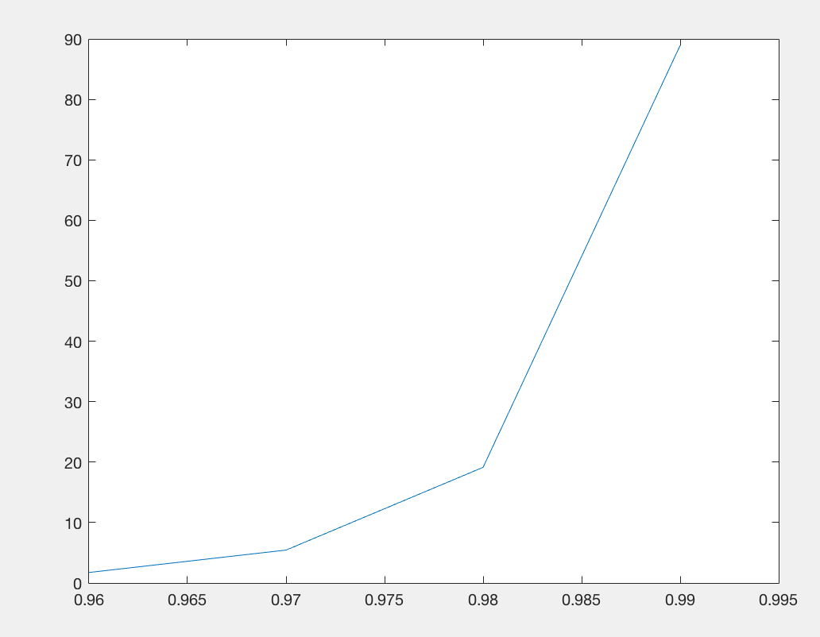

>> [S T] = find(OP(:,1)==0.97)

S =

11
12
13
14
15

T =

1
1
1
1
1

>> SubOP=OP(S,:)

SubOP =

0.9700 100.0000 5.4446 31.3530 5.0000
0.9700 200.0000 0.4447 101.3696 4.0000
0.9700 300.0000 0.0313 194.8113 4.0000
0.9700 400.0000 0.0020 261.9878 4.0000
0.9700 500.0000 0.0001 305.7642 4.0000
>> plot(SubOP(:,2),SubOP(:,3))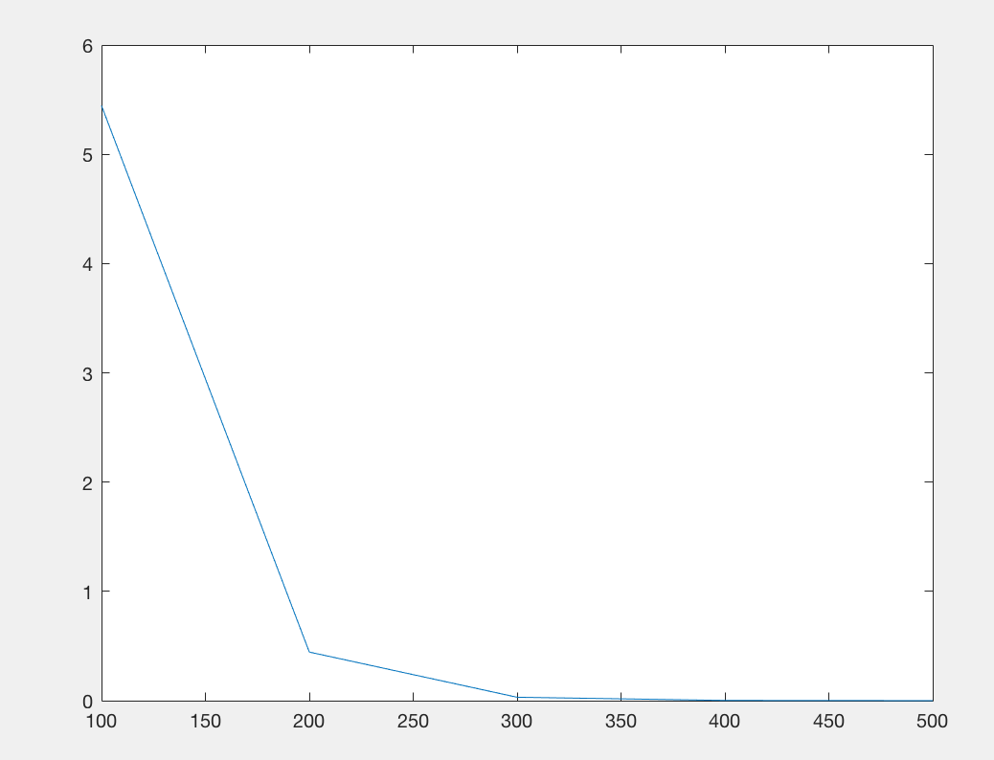

Use the information you gathered in the above two tasks to discuss why epidemics die out.

The first graph shows that when there is a higher probability of interacting with a case (a lower q), there will be a smaller final population of susceptibles because more people have been infected and then achieved immunity (i.e. no longer susceptible).

The second graph shows that the larger the initial population of susceptibles, the smaller the final population of susceptibles will be even when the probability of an individual interacting with a case remains constant. This seems counterintuitive, but it makes sense because having a larger initial susceptible population means that more people will become infected when interacting with a case than in a population with few susceptible people (even though the probability of interaction between the two are identical).

As an epidemic spreads, the amount of people infected and becoming immune rises until a threshold is reached where the probability of further spread is rare (i.e. herd immunity is reached and majority of people are either immune or will have very low chance of coming into contact with a case). This threshold is what causes epidemics to die out.

Compare model prediction with measles epidemic data (Abbey, 1982).
A measles epidemic within a boarding school fits the assumptions of the model. The file Aycock.txt contains data from a measles epidemic in a New England boys' boarding school in 1934. The three columns in this data set contain the time interval (12 day periods corresponding to the incubation period), the reported number of cases, and the reported number of susceptibles.

Task3:
Find the value of q that looks to be the best fit of the data and use it to plot the observed number of cases (using markers) with the expected number of cases (using a continuous line). To learn about how to designate marker and line types, type help plot.
- Plot the observed number of cases over time
- Plot the expected number of cases over time (for q = 0.97)
- Try increasing or decreasing q until you find a curve that provides a good fit for the data

Note:
- You will need to take into account the fact that the model starts at t=1, whereas the data starts at t=0.
- Don't forget to set the initial condition in your model. In the data set, Aycock.txt, Sinitial = 117.
- Since the Aycock data only has 6 data points you will need to modify the model appropriately.

% The Reed-Frost model
% Note: The plotting part of the script is commented out
% If you would like you could uncomment to get the plots
j = 0;
OP = zeros(20,5);
for q = .99:-0.01:.96
for si=100:100:500
j=j+1;
hold off;
c=zeros(15,1);
s=zeros(15,1);
c(1)= 1;
s(1)= si;
for i=1:15
c(i+1) = s(i)*(1 - q^c(i));
s(i+1) = s(i) - c(i+1);
end
plot(c,':');
hold on;
plot(s,'--');
axis([1 16 0 si]);
xlabel('Time');
ylabel(' Cases ( ... ) Susceptibles ( ---- ) ');
Ti = ['q = ' num2str(q)];
title(Ti);
figure;
[Mx I] = max(c);
OP(j,:) = [q si s(16) Mx I];
end
end

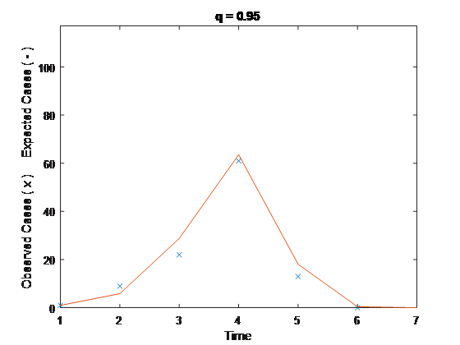

Task4: Assessing goodness-of-fit
The script ReedFrost2 contains the necessary comments to complete Task 4.

The following goodness-of-fit equation is already coded in the script.

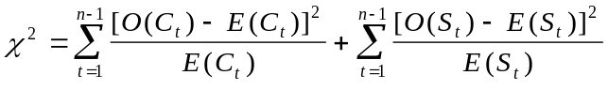

where O(.) are observed values and E(.) are expected or predicted values. Fine tune your best-fit estimate for q.

% The Reed-Frost model
j = 0;
si = 117;
Fit = zeros(100,2);
for q = .97:-0.001:.95
j=j+1;
c=zeros(15,1);
s=zeros(15,1);
c(1)= 1;
s(1)= si;
for i=1:15
c(i+1) = s(i)*(1 - q^c(i));
s(i+1) = s(i) - c(i+1);
end
chiC = sum( ( aycock(:,2) - c(1:6) ) .* ( aycock(:,2) - c(1:6) ) ./ c(1:6) );
chiS = sum( ( aycock(:,3) - s(1:6) ) .* ( aycock(:,3) - s(1:6) ) ./ s(1:6) );
chiT = chiC + chiS;
Fit(j,:) = [q chiT];
end
Fit(1:j,:)
plot(aycock(:,1)+1,aycock(:,2),'*');
hold on;
plot(c);
hold off;

>> ReedFrost2

ans =

0.9700 137.1518
0.9690 123.9522
0.9680 113.5891
0.9670 106.0759
0.9660 101.4610
0.9650 99.8260
0.9640 101.2863
0.9630 105.9954
0.9620 114.1513
0.9610 126.0055
0.9600 141.8738
0.9590 162.1488
0.9580 187.3125
0.9570 217.9515
0.9560 254.7721
0.9550 298.6169
0.9540 350.4828
0.9530 411.5404
0.9520 483.1556
0.9510 566.9127
0.9500 664.6403

Based on the above output, the best fit would be at q=0.965, because it is the q value associated with the lowest formula output. The lowest formula output would indicate the lowest amount of difference between the observed and expected values.

Why might you get a different answer in Task 3 and Task 4?
The process from task 3 is based on our empirical sample data. It is subject to randomness and to the effects of outliers. The formula from task 4 is a statistical goodness of fit test, which is a deterministic model and will serve as a hypothesis test to see how good our task 3 model is.

Provide two reasons, either related to the data or to the model structure, that could explain why the 'best' fit may still be a poor fit.

Because the sample size of the data is small, the model may not actually be useful for larger or different populations (not generalizable). Additionally, the goodness of fit model may not take into account stochasticity that will be seen in real-life scenarios. In other words, the model may not account for random processes or extreme values.

References

Abbey, H. 1952. An examination of the Reed-Frost theory of epidemics. Human Biology 24: 201-233.
Westing, A. H. 1981. A note on how many humans that have ever lived. Bioscience 31: 523524.

